Trello board screenshot:

1. This is our original trello board screenshot. There are 7 sections.

Product backlog items displays all product backlogs.

Current backlog item shows the product backlog the team focus on.

To do list means the job we need to do in this period of time.

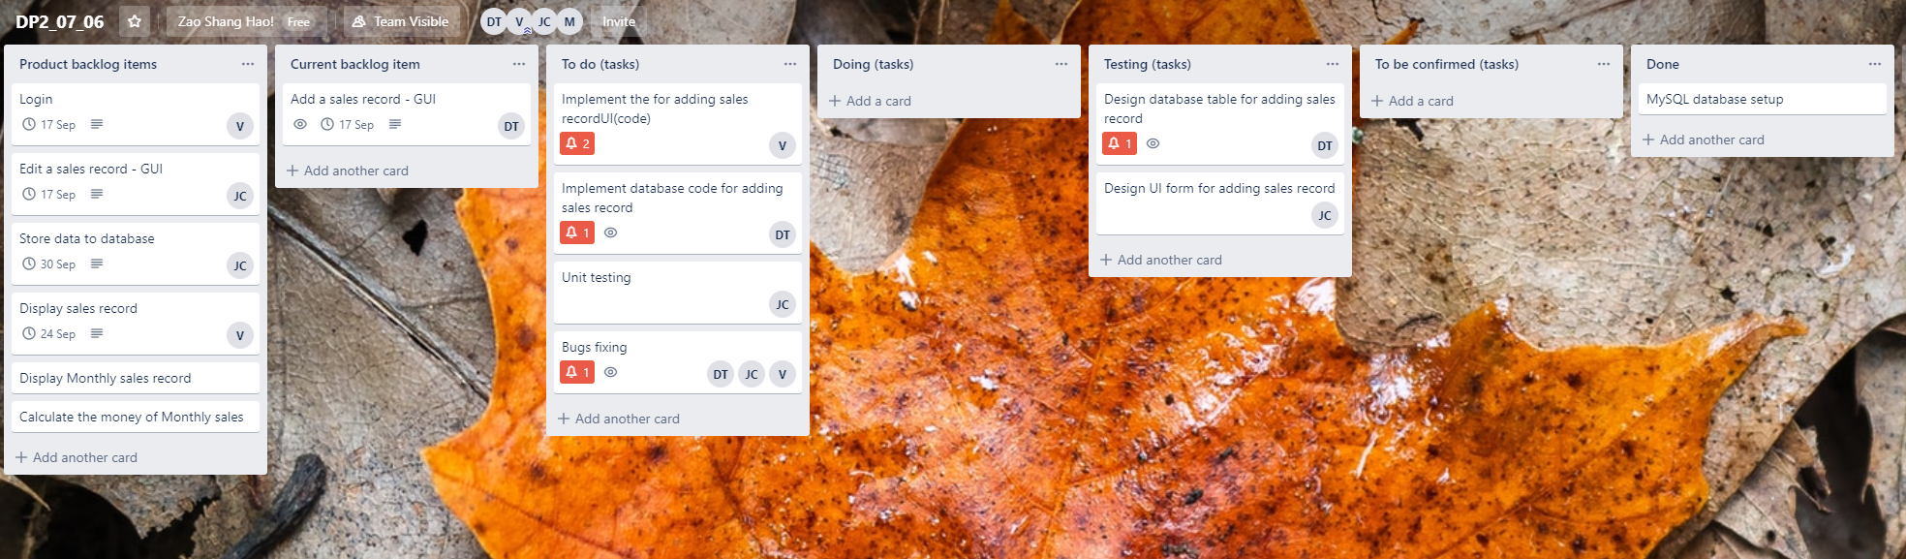

2.

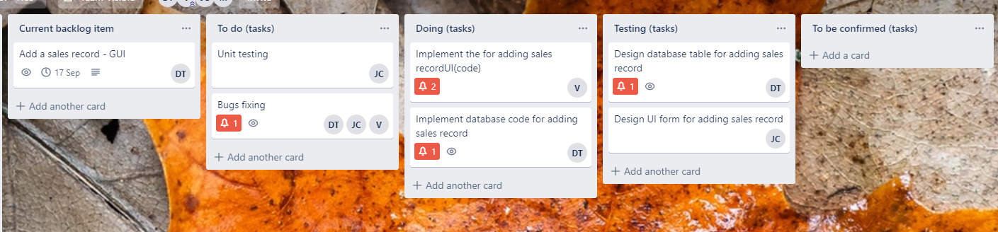

3.

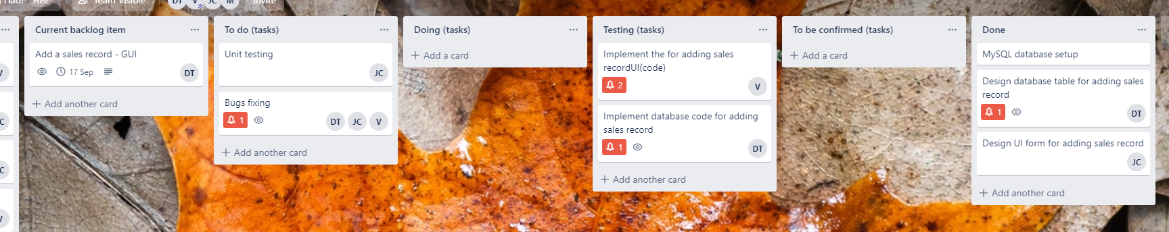

4.

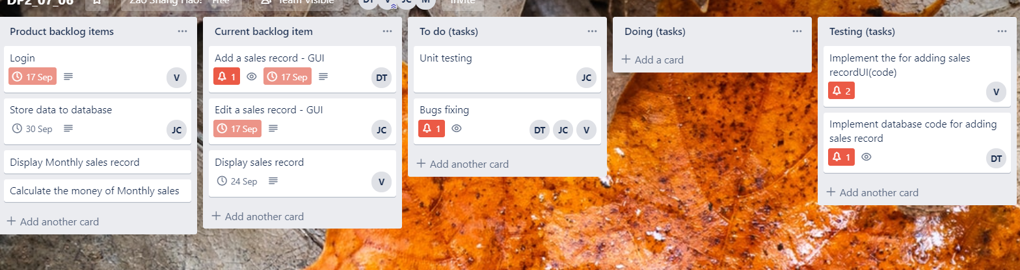

5.

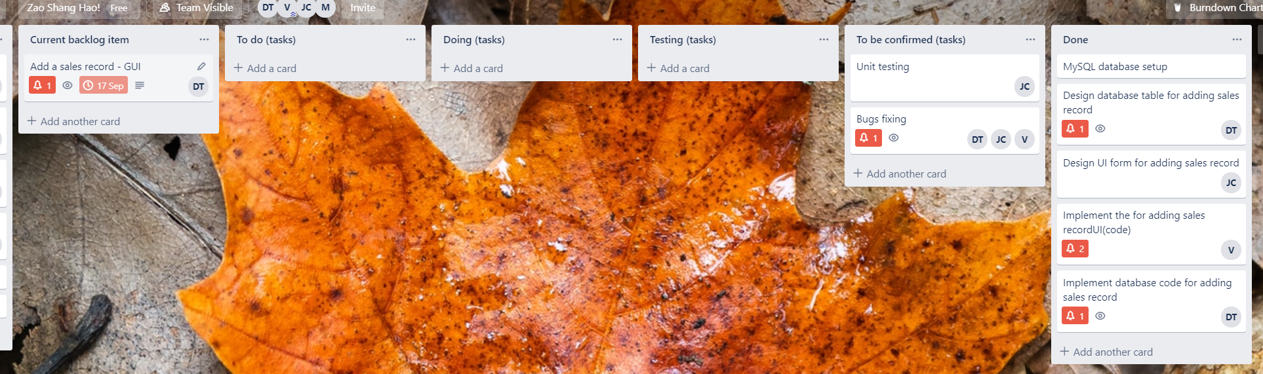

6.

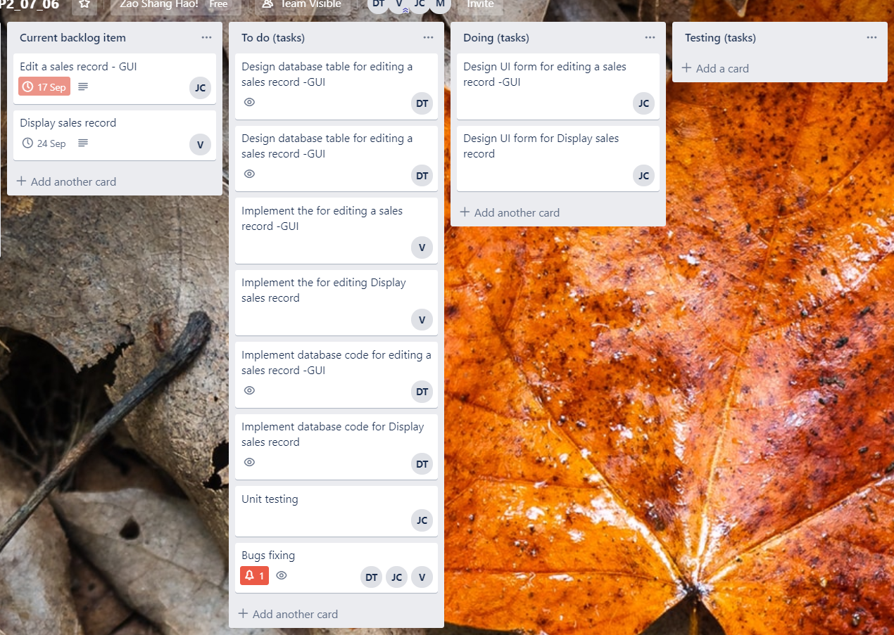

Meeting minutes:

[DP2_07_06] meeting minutes 1

|  |  |
| --- | --- |
| Location: | [BA building 707] |
| Date: | [09/09/2019] |
| Time: | [1:00-2:30 pm] |
| Attendees: | [The Vinh Ly, Junting Cen, Dinh Thai |

# Agenda items

1. [Plan the order of the sprint 1 items.]
2. [Discuss another four-meeting time which is suitable for everyone.]

| Action items | Owner(s) | Deadline | Status |
| --- | --- | --- | --- |
| [Discuss the order of  Sprint 1 items.] | [Dinh Thai] | [09/09] | [complete] |
| [Determine the meeting time: 12/09; 16/09; 19/09; 21/09] | [Junting Cen] | [09/09] | [complete] |
| [Discuss the priority work  Before meeting: watch the related video. Download the Xampp, database connector] | [The Vinh Ly] | [12/09] | [in Progress] |

[DP2_07_06] meeting minutes 2

|  |  |
| --- | --- |
| Location: | [First Floor of Library] |
| Date: | [10/09/2019] |
| Time: | [2:30- 4:00 pm] |
| Attendees: | [The Vinh Ly, Junting Cen, Dinh Thai |

# Agenda items

1. [Set up basic database.]
2. [Discuss window form of add sales record.]
3. [Use Git Hub to share database data.]

| Action items | Owner(s) | Deadline | Status |
| --- | --- | --- | --- |
| [Set up the basic database features, such as product items data, staff data] | [Dinh Thai] | [10/09] | [complete] |
| [Search online for add sales record window form design. Discuss and finalize the design format.] | [Junting Cen] | [10/09] | [complete] |
| [Use Xampp to generate the database file, and then put the file to Git hub. Since the database is stored in local host, then we just import the database file to local host when we need to use it. ] | [The Vinh Ly] | [10/09] | [complete] |

[DP2_07_06] meeting minutes 3

|  |  |
| --- | --- |
| Location: | [Online meeting] |
| Date: | [11/09/2019] |
| Time: | [2:30-3:00 pm] |
| Attendees: | [The Vinh Ly, Junting Cen, Dinh Thai] |

# Agenda items

1. [Discuss the add sales record design]
2. [Discuss edit sales record design]
3. [Discuss weekly sales record design]
4. [Discuss the work need to be done before next meeting]

| Action items | Owner(s) | Deadline | Status |
| --- | --- | --- | --- |
| [Performance add sales record function.] | [Dinh Thai] | [11/09] | [complete] |
| [Discuss the window form of edit design and weekly sales display. Make change based on the peer review.] | [Junting Cen, The Vinh Ly] | [15/09] | [In progress] |
| [Edit sales record and weekly sales display start.] | [Junting Cen, The Vinh Ly] | [15/09] | [In progress] |
|  |  |  |  |
|  |

[DP2_07_06] meeting minutes 4

|  |  |
| --- | --- |
| Location: | [Library] |
| Date: | [12/09/2019] |
| Time: | [4:30 – 8:00 pm] |
| Attendees: | [The Vinh Ly, Junting Cen] |

# Agenda items

1. [Combine weekly sales display design to add sales record design(only code part)]
2. [Fix bug of Edit design]

| Action items | Owner(s) | Deadline | Status |
| --- | --- | --- | --- |
| [Discuss how to use model, controller and view to implement weekly sales record design.] | [The Vinh Ly] | [12/09] | [complete] |
| [Explore how to implement edit sales record by using model, controller and view.] | [Junting Cen] | [15/09] | [In progress] |
| [Fix the bug of Edit sales record class] | [The Vinh Ly] | [15/09] | [In progress] |
|  |  |  |  |
|  |

[DP2_07_06] meeting minutes 5

|  |  |
| --- | --- |
| Location: | [Library] |
| Date: | [13/09/2019] |
| Time: | [12:30 – 2:30 pm] |
| Attendees: | [The Vinh Ly, Junting Cen, Dinh Thai] |

# Agenda items

1. [Change the design feature based on peer review]
2. [Fix the bug of opening child window form instead of parent window form]
3. [Discuss the burndown chart, meeting minutes, Trello board]
4. [plan for the rest product item of sprint 1.]

| Action items | Owner(s) | Deadline | Status |
| --- | --- | --- | --- |
| [Since we think it is better and easier to implement edit feature as updating sales record in database directly, we change our edit design to this approach. Keep the window form design and change the code. ] | [The Vinh Ly] | [13/09] | [complete] |
| [Fix the bug of opening child window form and close parent window form (not hide it)] | [Junting Cen] | [13/09] | [complete] |
| [Review the trello board and burndown chart screenshot and ask the tutor for feedback.]  [Discuss and plan for the rest of product backlog. We left login in, weekly sales, monthly sales and yearly sales record display. Team leader allocated the tasks to every team members. ] | [Dinh Thai]  [Dinh That] | [13/09]  [13/09] | [complete]  [complete] |

Git Hub repositories

1.

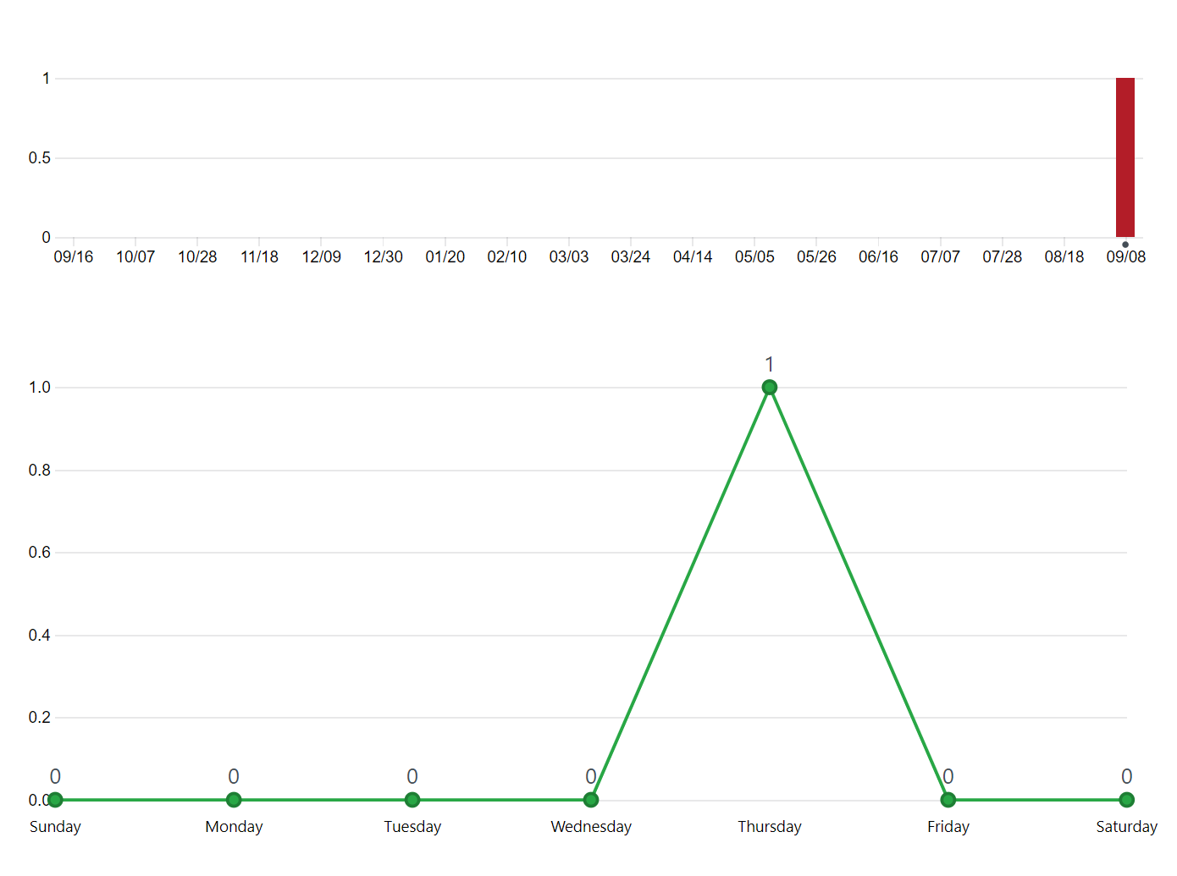

2.

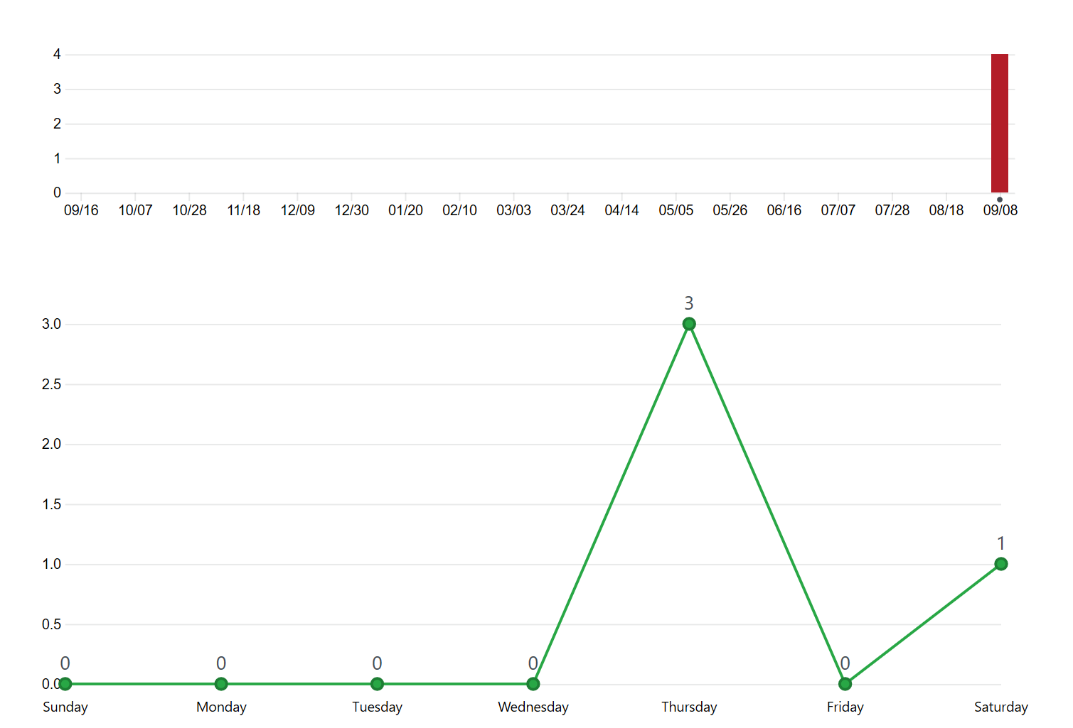

3.

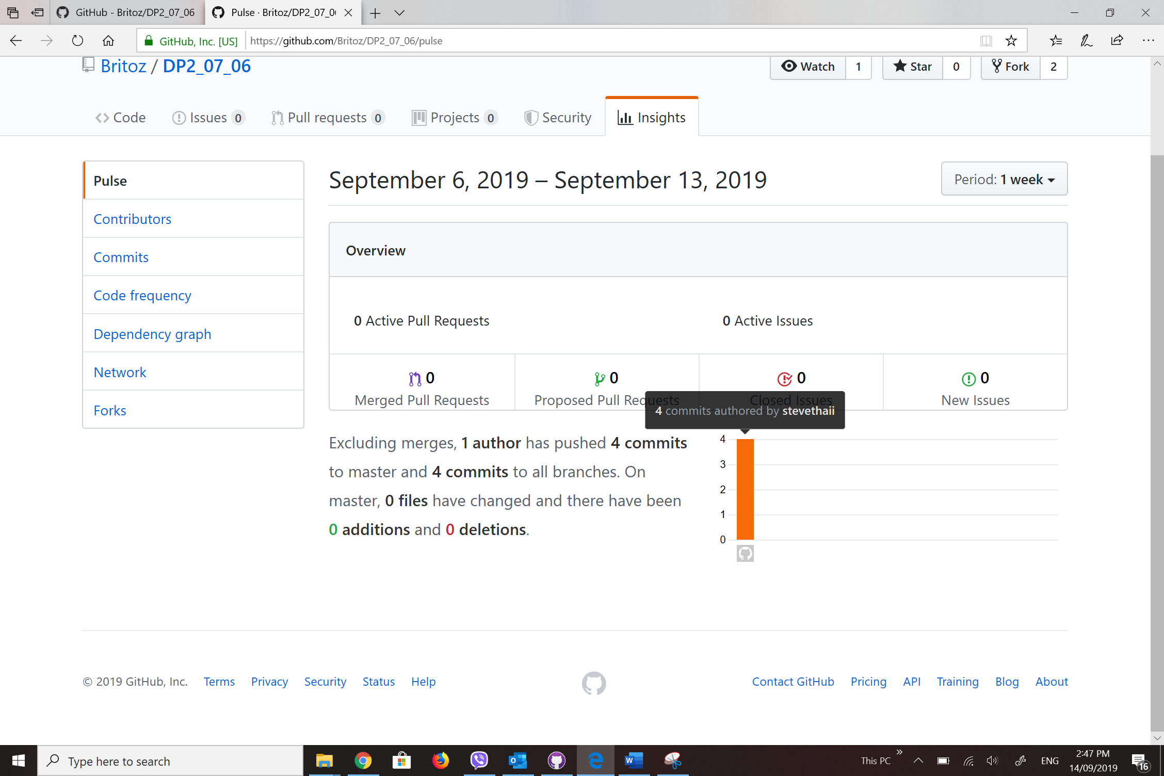

Work burn dart chart:

